**Types of Applications – Based on Who is maintaining and installing**

* Overview  
  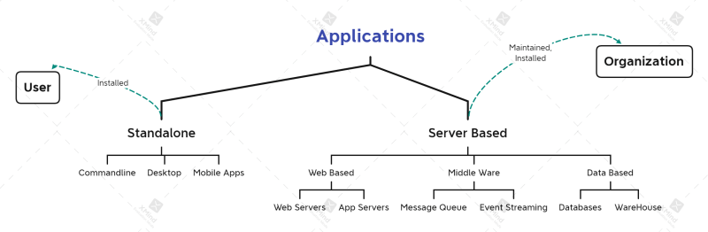
* Organizations are responsible for
  + installing and maintaining servers
  + maintaining Standalone applications
* Users install standalone applications

**How organizations maintain Servers**

* Organizations maintain Datacenters
* Datacenters will have multiple racks
* Each rack will get parallel power supply and parallel network connection, reason for this is failures should not be propagated.  
  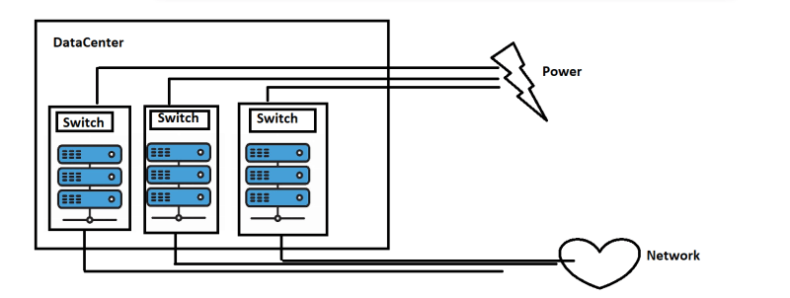
* **Server racks contain blade servers**  
  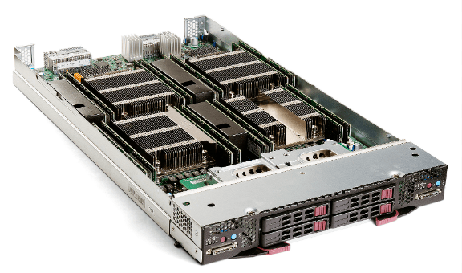

**Running applications on Servers**

* Generation 1: Running applications directly on physical server
  + Install some OS (Server OS)
  + Install applications on top of it
  + Problems:
    - ROI (Return on Investment) is very time taking and long
  + Costs:
    - Capex (Capital expenditure)
    - Opex (Operational Expenditure)

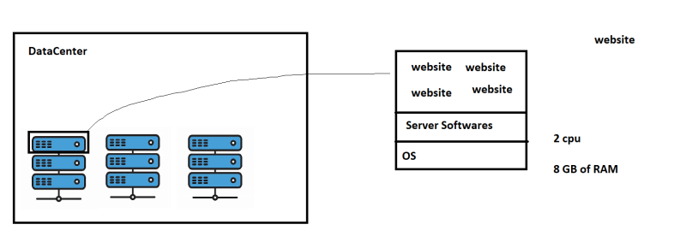

* Generation 2: Hypervisors became popular
  + Hypervisor has two flavours
    - Install directly on physical servers  
      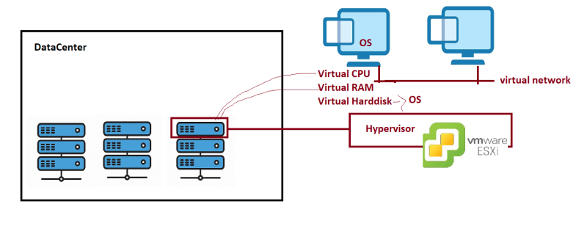
    - Install on existing os in physical server